
Africa Regional Media Hub
United States Department of State

MEDIA ADVISORY | February 3 Digital Press Briefing with General Dagvin R.M. Anderson, U.S. Air Force Commander, U.S. Africa Command on AFRICOM priorities on the African continent.

EVENT: Please join us on Tuesday, February 3, 2026, for a virtual press briefing with General Dagvin R.M. Anderson, U.S. Air Force Commander, U.S. Africa Command (AFRICOM). As he concludes his first six months as commander, Gen. Anderson will provide insights into AFRICOM’s key priorities—emphasizing a partner-led approach to security cooperation—while reaffirming the United States’ long-term commitment to Africa’s security, stability, regional sovereignty, and shared prosperity in alignment with U.S. national interests. This virtual press briefing will conclude with a question-and-answer session with participating journalists.

DETAILS:

Speaker: General Dagvin R.M. Anderson, U.S. Africa Command (AFRICOM)
Date: Tuesday, February 3, 2026
Time: 14:00 SAST Johannesburg | 12:00 GMT | 07:00 EST Washington, D.C.
Language: English. With simultaneous French interpretation.
Ground Rules: The briefing will be on the record.
Login Info.: To be provided upon RSVP.
Zoom RSVP: Please RSVP by clicking here
Twitter: Join the conversation #AFHubPress and follow us on @AfricaMediaHub.

BIOGRAPHY:

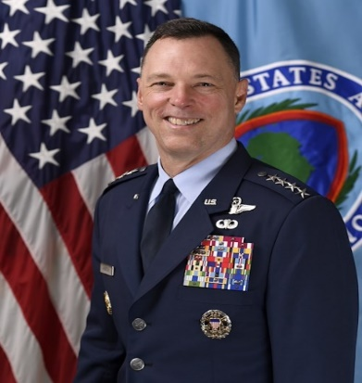
General Dagvin R.M. Anderson, U.S. Air Force Commander
U.S. Africa Command (AFRICOM)

General Dagvin R.M. Anderson is the seventh commander of U.S. Africa Command (AFRICOM) headquartered in Stuttgart, Germany. As the commander, he is charged with leading one of the U.S. Department of Defense’s seven geographic combatant commands in ensuring the responsibility of U.S. military operations and activities to protect and advance U.S. national interests in Africa.

Before taking command of AFRICOM, Gen. Anderson served as the Director for Joint Force Development, Joint Staff, at the Pentagon. In that role, he was responsible for envisioning and developing the future joint force and advocating for the future warfighter.

A native of Ypsilanti, Michigan, Gen. Anderson earned his commission as a distinguished graduate of the Air Force ROTC program at Washington University in St. Louis.

As a command pilot with more than 3,400 flight hours, including 738 combat hours, Gen. Anderson has flown 16 different aircraft throughout his career. Notably, he has flown the KC-135R, MC-130E, and U-28A operationally in several global contingencies.

His previous staff and joint assignments include serving as the Vice Director of Operations on the Joint Staff; Commander of Special Operations Command-Africa; Deputy Director for Operations at U.S. Indo-Pacific Command Headquarters; Special Assistant to the Commander and Director of the Commander’s Strategic Initiative Group for United Nations Command-Combined Forces Command-U.S. Forces Korea; Senior Aviation Advisor for Counter-Terrorism Operations for the Office of the Under Secretary of Defense for Policy, Special Operations/Low-Intensity Conflict; and Deputy Director of the Commander’s Action Group for United States Special Operations Command.

He has commanded at five different echelons to include commanding JTF-Quartz, a joint task force directed with the responsibility for overseeing the repositioning of U.S. forces from Somalia.

Gen. Anderson’s military academic honors include being a Fellow at the Weatherhead Center for International Affairs at Harvard University and an Olmsted Scholar at Masaryk University in the Czech Republic.

LOGISTICS:

- Participants should log in to join the conference 10 minutes early.
- Participants will be asked to type in their name, press affiliation, and location.
- The speaker will give brief opening remarks, and then the moderator will open the floor to questions.
- Journalists may submit written questions in advance when registering on Eventbrite or via e-mail to afmediahub@state.gov.
- Participants will be instructed to type their questions or indicate to the moderator in the chat if they wish to ask a live question.
- If you experience technical difficulties during the briefing, you may send an e-mail to afmediahub@state.gov to alert the moderator to any issues.
- A transcript will be available to registered journalists in, English and Portuguese following the briefing.
- Please note that the briefing will be audio only (no video).

