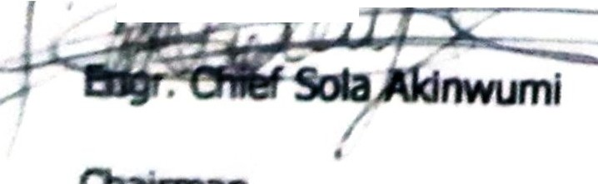
...
Isiaka Adegboyega O(etola in
paudtydmncis.
.. ;

I PC; 11 1 1■1 -I G B

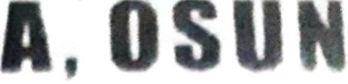
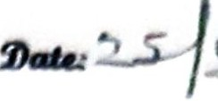
r; ;-, I
COMMUNIQUE
•Osun presided aver bv Engr. Olfef Sola Aklnwumf held her monthly
meeft,o tDdilw the 25"' May, 2021 and resolved as folkJws:
( ) That thts body paS9ed vote of oonfldence In the admintstratkln of His Exceflencf, Afhaji lsiaka Adegboyega Oyetola as Governor of Osun State and to the party leadet stuq under Prince Gboyega Famodun as the State Party Chairman in Osun
State. That this body re-affirmed her support for Governor Oyetola's Second term
ambition.
- That the APC, Igbimo -Agba Osun dissociated itself completely from a recent
◄
radio interview whereby a member of our body, Elder Adelowo promoted internal
divisions within the party partirularty on the formation of -ihe Osun Progressives
- TtF and acmrdingly suspends the said Elder Adebiyi Adelowo from the
membership of APC lgbimo Agba Osun forthwith.
- That the body enjoined fM!IY member of our party to remain committed, loyal
and resolute towards strengthening of our party in Osun state.
- That all dtizerld Osun state are appreciated for supporting His Excellency, Mr.
his sb'ides towards of the state amidst

Ollirman

